**GIT HUB ASSIGNMENT**

**SECTION 2(GIT BRANCHING)**

**22.create an empty directory ‘Assignment ‘ & cd to Assignments’**

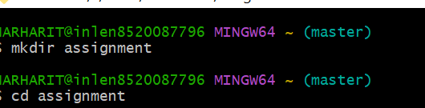

**23.Create a file README.txt inside Assignment & cd to assignment and commit README.txt file**

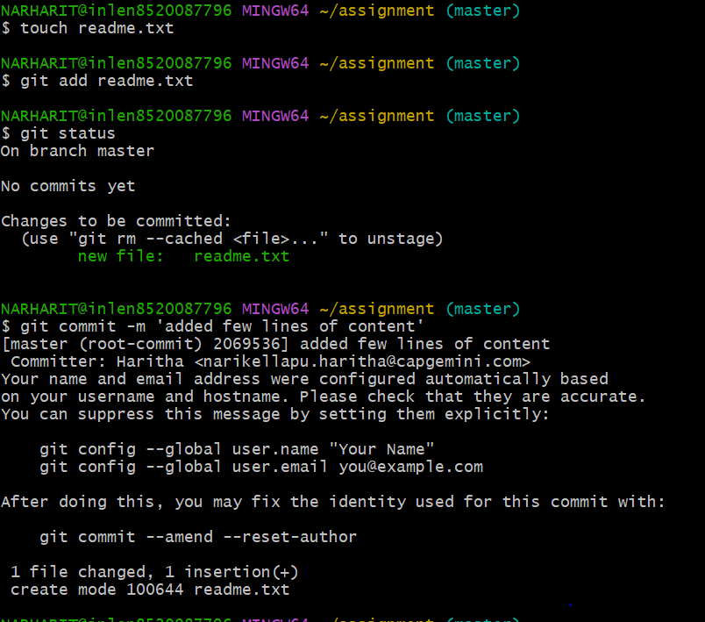

**24.Now create a new branch html assignment**



**25.Switch to html assignment branch**



**26.Copy all HTML assignment inside assignment folder**

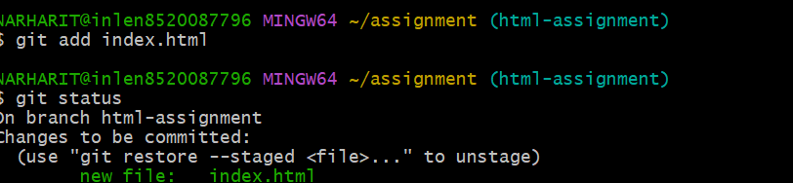

**27.Commit HTML assignment into html assignment branch**

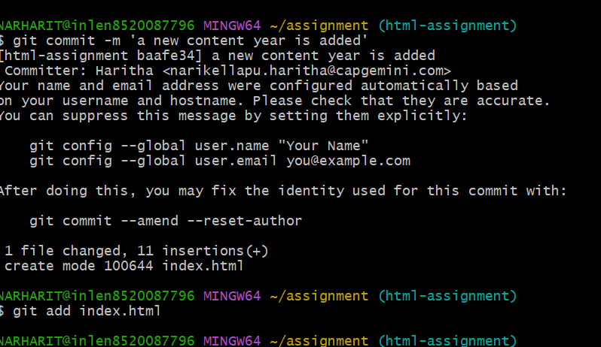

**28.Make minor changes into few files belonging to html assignment branch**